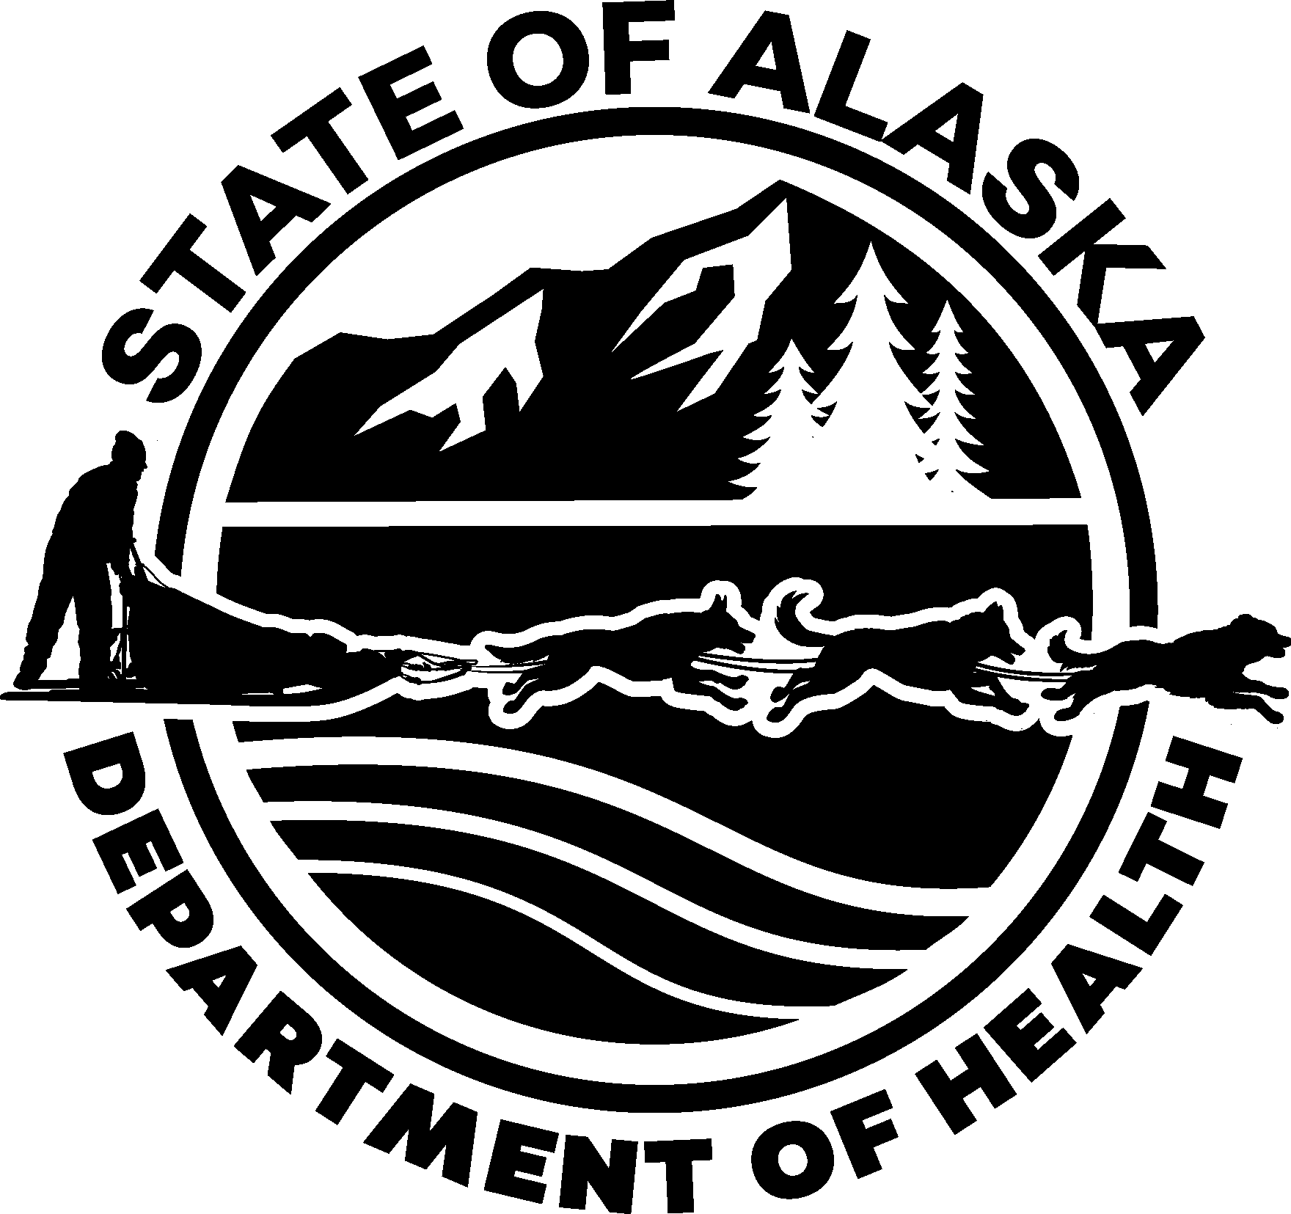
Application for Services
State of Alaska Department of Health
Division of Public Assistance
https://health.alaska.gov/dpa

If you need help filling out this form or have questions, please tell us — we can help!

How do I apply?
Programs
Federally Facilitated Marketplace Private health insurance plans, free or low-cost savings plan, and tax credits that pay for insurance.
Medicaid
Offers medical coverage to low-income individuals, people over 65, disabled, blind, pregnant women, and families with dependent children. Also helps with Medicare Parts A and B premiums.
Chronic & Acute Medical
Assistance
Helps people with specific illnesses who don’t qualify for Medicaid and have little or no income.
Supplemental Nutrition Assistance Program (SNAP) Helps people buy food.
Temporary Assistance Program Gives monthly cash payments to eligible families with children.
Adult Public Assistance
Gives monthly cash payments and medical assistance to eligible elderly, blind, and disabled persons.
General Relief Assistance
Helps eligible individuals and families with emergency rent and utility needs. Also helps with burial costs.
Use this application to apply for public assistance programs. Only your legal name, address, and signature are required on page 7 of this application form to secure a benefit start date.
For SNAP, your benefit start date begins the date we receive your completed page 7. Adult Public Assistance, Medicaid, and benefits from other programs may start on a different day

Apply for Medicaid faster online
- Visit www.healthcare.gov or www.my.alaska.gov to apply online

How long will it take?
It may take up to 45 days to process your application.
SNAP applicants may be entitled to expedited service. The following households may be eligible to receive SNAP benefits within 7 days:
  - Households that have less than $100 in cash or money in the bank
  - Households whose monthly gross income (before deductions) is less than $150
  - Households whose costs for rent/mortgage/utilities are more than their monthly gross income, cash, money in the bank

What you may need to apply for health insurance
  - Social Security numbers (or document numbers for any legal immigrants who need insurance)
  - Birth dates
  - Employer & income information for everyone in your household (for example — pay stubs, W-2 tax form - Wage and Tax Statements) Your income and family size help us decide which health insurance programs you qualify for. We need to know about everyone on your tax return (you don’t need to file taxes to get health coverage or public assistance services)
  - Policy numbers for any current health insurance
  - Information about any job-related health insurance available to your family

Do I have to complete an interview?
  - An interview is required before we can determine if you are eligible for certain public assistance programs. You may schedule an interview at the Public Assistance office or with your local Fee Agent. Your application will be denied if you do not complete an interview.
  - If you need a language interpreter, call 1-800-478-7778 and we will provide one at no cost to you. If you are deaf, hard of hearing, or have a speech disability, dial 711 to reach an Alaska Relay Communications Assistant.

Information Page — Read and keep this page for your records.

What you may need to give us.

Identity:  birth certificate  driver’s license or state identification card health benefits identification card school or work identification  passport | Earned Income:  pay stubs (for the past 30 days) employer statement of gross wages self-employment bookkeeping records income tax forms
Residency:  utility bills such as electric, gas, or water rental agreement or mortgage statement that shows your address | Unearned Income:  agency letter showing money received such as Social Security (SSI), Veteran’s Affairs benefits (VA), child support, alimony, unemployment, and retirement
Immigration Status:  immigration or naturalization papers (not required for U.S. citizens or for ineligible people who are applying for SNAP for their U.S. citizen children) | Child Support:  paternity, custody and support orders divorce or dissolutiondecrees
Medical Expense Deductions:  For households with elderly (age 60 or older), blind, or disabled members only:  billing statements  itemized medical receipts such as for prescription drugs  Medicare card indicating Part B coverage repayment agreement with physician | Other Documents Which May be Required:  bills or receipts for childcare or dependent adult care  proof of application for Supplemental Security Income (SSI)  eviction notices or utility shut off notice  copy of court order showing your child support obligations and proof of payment

Your appointment is on:

Date/Day Time Phone

Location/Interviewer Fax

Information Page — Keep this page for your records.

Your Rights and Responsibilities

What if I disagree with a decision made?
You have the right to discuss any action taken on your application or case with a caseworker or supervisor. If you think the Division of Public Assistance or Federally Facilitated Marketplace has made a mistake on your health insurance determination or the Division of Public Assistance has made a mistake on your benefits determination, you can appeal its decision. To appeal means to tell someone at the Division of Public Assistance or the Federally Facilitated Marketplace that you think the action
is wrong, and ask for a fair hearing review of the action. The request for Supplemental Nutrition Assistance Program (SNAP) and Medicaid may be made to any employee of the Division in person, by telephone, or in writing; requests for all other programs must be made in writing. SNAP fair hearing requests must be made within 90 days from the effective date of the action. Fair hearing requests for all other programs must be made within 30 days from the date of the notice. If requested, the Division will assist you in making a hearing request. If your disagreement has to do with medical billing or services, contact the Medicaid Recipient Information Helpline at 1-800-780-9972.
If you request a fair hearing before the effective date of the action, you may continue to receive benefits until a hearing decision is made. If you do not request a fair hearing before the effective date of the action, you can still appeal but benefits will not be continued. You can always re-apply for benefits while waiting for your hearing. At the hearing you may represent yourself or be represented by a legal representative. You may qualify for free legal advice and representation by contacting the Alaska Legal Services Corporation at (907) 272-9431 or 1-888-478-2572.

My right to appeal
I know that I can find out how to appeal by contacting the Division of Public Assistance or the Marketplace at 1-800-318-2596. I know that I can be represented in the process by someone other than myself. My eligibility and other important information will be explained to me.

When do I need to report changes?
You must report changes in your household within 10 days of when you know of the change. If you receive Alaska Temporary Assistance and a child leaves your home, you must report this within 5 days.

What changes do I need to report?
If you receive Health Insurance Benefits authorized by the Federally Facilitated Marketplace or Public Assistance Medicaid, you must report any and all changes to information provided in this application, including changes in your medical insurance.
If you receive Supplemental Nutrition Assistance Program and you do not receive benefits from any other program, you must report when your household’s total gross income goes over the income limit for your household size and if someone in your household has lottery or gambling winnings of $3,500 or more in a single game. If your household contains a member subject to
the ABAWD time limits, you must report when their work hours fall below 20 hours per week.
If you receive public assistance services, the changes you must report include, but are not limited to the following:
- Starting or stopping a job, change in wage rate, change from part-time to full-time, or full-time to part- time
- When money you receive from sources other than working changes by more than $50
- Someone moves into or out of your home
- You move or get a new mailing address
- Your household gets a vehicle
- Your household has more than $2250 total in cash and money in bank
- Changes in your child support payment or obligation
- Changes in your medical insurance if you or anyone in your household gets Medicaid
- Pregnancy changes

Will I need to work?
To receive Alaska Temporary Assistance or Supplemental Nutrition Assistance Program, you may have to participate in work activities. Alaska Temporary Assistance participants must prepare a Family Self-Sufficiency Plan for becoming financially independent. You must participate in approved work activities unless you qualify for an exemption. If you are an unmarried minor parent, to receive Alaska Temporary Assistance you must live with a parent or in another approved living arrangement and attend school or training. If you do not fulfill these work requirements or minor parent requirements, your benefits may be reduced or ended.

Read and keep this page.

What happens with my Child Support?
Alaska must collect child support and medical support from any parent who has the duty to pay support for a child receiving Alaska Temporary Assistance or Medicaid. This includes any money owed to you at the time you apply, as well as current and future child support payments. Any child support payments given or paid to you while receiving Alaska Temporary Assistance benefits must be reported and turned over to the State immediately. To change a child support order, you must obtain a new court order or get permission from the Child Support Services Division (CSSD). If you believe you have a good reason not to cooperate with CSSD for these programs, you must tell your caseworker immediately. You may be asked to provide information to support your reason.

When you apply for Alaska Temporary Assistance you must:
- Sign over to CSSD your right to receive and keep child support payments due to you or a child on Alaska Temporary Assistance.
- Cooperate with CSSD in establishing paternity.
- Agree not to make purchases with or to access the cash benefits on your EBT card at ATMs that are located in bars, liquor stores, gambling or adult entertainment establishments.

When you apply for Medicaid you must:
- Assign to the State of Alaska all rights to any medical support or other third party payments to the extent the department has paid medical assistance for care and services for you or your minor children.
- Cooperate with and assist the department in identifying and providing information concerning third parties who may be liable to pay for care and services received for you or your minor children.
- Agree to apply for all other available third-party resources that may be used to provide or pay for the cost of care or services received by you or your minor children or that may be used to reimburse the state for the cost of care or services received.
- Cooperate with CSSD in establishing paternity.
- If applying for long-term care services, including Home and Community Based Waiver services, assign to the State of Alaska as a remainder beneficiary, or as the second remainder beneficiary after your spouse or minor or disabled child, for any interest that you may have in an annuity up to the amount of Medicaid benefits received.

Can the State of Alaska take my estate?
The estate of an individual age 55 years of age or older who received Medicaid benefits may be subject to a claim for recovery. This is limited to the reimbursement of services received while the recipient was in a medical institution, including a nursing home or other medical institution, or was receiving home- and community-based services. Under limited conditions, the State of Alaska may place a lien on a recipient’s home. However, most estate recovery is conducted after the death of the recipient or the recipient’s surviving spouse, if any, and only at a time when the recipient has no surviving child under age 21 and no surviving child who is blind or disabled.
Responsibility for Overpayment
If you receive an overpayment of Public Assistance benefits or receive services to which you are not entitled, you may be financially responsible for repaying the overpayment or cost of services to the State of Alaska. This may be true even if the overpayment or improper authorization of services is due to an error on the part of the Department of Health. By accepting benefits or services, you must understand and agree that you may have a responsibility for the
repayment of benefits or services to which you were not entitled.
How are my rights protected?
The Division of Public Assistance will collect information, including the Social Security number (SSN) of each household member who is applying for Supplemental Nutrition Assistance Program, Alaska Temporary Assistance, or Medicaid, to determine eligibility for public assistance benefits. The Division will verify this information through computer matching programs, including the Income and Earnings Verification System (IEVS). This information will be used to monitor compliance with program regulations and for program management. The Division may disclose this information to other Federal and State agencies for official examination, to law enforcement officials for the purpose of apprehending persons fleeing to avoid the law, and to private claims collection agencies for claims collection action. The Division may verify immigrant status of household members by contacting the U.S. Citizenship and Immigration Services (USCIS). Information obtained from these agencies may affect your eligibility and level of benefits.
Providing the requested information, including the SSN of each household member for whom you are seeking benefits, is voluntary. However, failure to provide this information will result in the denial of benefits to each individual failing to provide an SSN. Any SSN provided will be used and disclosed in the same manner, regardless of the eligibility of the individual. The Division of Public Assistance can assist you in applying for a Social Security Number if you are seeking benefits and do not have one.
When you sign the application for assistance and use Medicaid or Chronic & Acute Medical Assistance, you consent to release medical records and information about yourself and any other person you are applying for to the Department of Health (DOH). Upon request, any person who has medical records and information or the custody of such records shall release those records to the Department or a representative of the department.

Health or medical information DOH may have about you is protected under the Health Insurance Portability and Accountability Act (HIPAA) of 1996. This federal law provides you with certain rights about how your health information is used and disclosed. The law allows you to find out how DOH used your health information, and how DOH has disclosed your health information outside of DOH. The law also limits the release of information about you to the minimum amount necessary for the purpose of the disclosure and allows you to examine and obtain a copy of your own health records and to request corrections to those records.
You can get an electronic copy of the Notice of Privacy Practices at https://health.alaska.gov/fms/Documents/DOH-Notice-of-Privacy- Practices.pdf or you can request a printed copy by emailing: privacyofficial@alaska.gov or by writing to: State of Alaska, DOH Privacy Official, P.O. Box 110650, Juneau, Alaska 99811-0650.
In accordance with federal civil rights laws and U.S. Department of Agriculture (USDA) civil rights regulations and policies, the USDA, its agencies, offices, and employees, and institutions participating in or administering USDA programs are prohibited from discriminating based on race, color, national origin, sex (including gender identity and sexual orientation), religious creed, disability, age, political beliefs, or reprisal or retaliation for prior civil rights activity in any program or activity conducted or funded by USDA. Programs that receive federal financial assistance from the U.S. Department of Health and Human Services (HHS), such as Temporary Assistance for Needy Families (TANF), and programs HHS directly operates are also prohibited from discrimination under federal civil rights laws and HHS regulations.
USDA provides federal financial assistance for many food security and hunger reduction programs such as the Supplemental Nutrition Assistance Program (SNAP), the Food Distribution Program on Indian Reservations (FDPIR) and others. To file a program complaint of discrimination, complete the Program Discrimination Complaint Form, (AD-3027) (found online at: How to File a Complaint, and at any USDA office) or write a letter addressed to USDA and provide in the letter all of the information requested in the form. To request a copy of the complaint form, call (866) 632-9992. Submit your completed form or letter to USDA by:
- mail: Food and Nutrition Service, USDA
1320 Braddock Place, Room 334, Alexandria, VA 22314; or
- fax: (833) 256-1665 or (202) 690-7442; or
- phone: (833) 620-1071; or
- email: FNSCIVILRIGHTSCOMPLAINTS@usda.gov.

For any other information regarding SNAP issues, persons should either contact the USDA SNAP hotline number at (800) 221-5689, which is also in Spanish, or call the state information/hotline numbers (click the link for a listing of hotline numbers by state); found online at: SNAP hotline.
HHS provides federal financial assistance for many programs to enhance health and well-being, including TANF, Head Start, the Low Income Home Energy Assistance Program (LIHEAP), and others. If you believe that you have been discriminated against because of your race, color, national origin, disability, age, sex (including pregnancy, sexual orientation, and gender identity), or religion in programs or activities that HHS directly operates or to which HHS provides federal financial assistance, you may file a complaint with the Office for Civil Rights (OCR) for yourself or for someone else.
To file a complaint of discrimination for yourself or someone else regarding a program receiving federal financial assistance through HHS, complete the form on line through OCR’s Complaint Portal at https://ocrportal.hhs.gov/ocr/. You may also contact OCR via mail at: Centralized Case Management Operations, U.S. Department of Health and Human Services, 200 Independence Avenue, S.W., Room 509F HHH Bldg., Washington, D.C. 20201; fax: (202) 619-3818; or email: OCRmail@hhs.gov. For faster processing, we encourage you to use the OCR online portal to file complaints rather than filing via mail. Persons who need assistance with filing a civil rights complaint can email OCR at OCRMail@hhs.gov or call OCR toll-free at 1-800-368-1019, TDD 1-800-537-7697. For persons who are deaf, hard of hearing, or have speech difficulties, please dial 7-1-1 to access telecommunications relay services. We also provide alternative formats (such as Braille and large print), auxiliary aids and language assistance services free of charge for filing a complaint. This institution is an equal opportunity provider.
Release
Your signature on this application gives the Federally Facilitated Marketplace, the Department of Health, its agents, and the Department of Law permission to ask for information about your health, finances, family and personal history. This information may be used to determine your eligibility for public assistance programs and, if a fraud investigation is launched, in administrative or criminal investigations of your eligibility for benefits. Your information will not be released for any other reason or to any other person or agency outside of the Federally Facilitated Marketplace, Department of Health or its representatives except as required by law.
The Release of Information will be in effect while you are an applicant or recipient of public assistance, and for any later investigations of your eligibility and receipt of benefits.
We'll check your answers using information in our electronic databases and databases from the Internal Revenue Service (IRS), Social Security, the Department of Homeland Security, and/or a consumer reporting agency. If the information doesn't match, we may ask you to send us proof. We may also contact other people or organizations including, but not limited to: the Alaska Housing Finance Corporation, the Department of Fish and Game, the Department of Labor, the Department of Law, the Department of Military and Veterans Affairs, the Department of Public Safety, the Department of Revenue, U.S. Citizenship and Immigration Services, employers, financial institutions, landlords, local governments, Native corporations, private individuals, public assistance program contractors and grantees, school authorities, the Social Security Administration, stock brokerage firms, and tax assessors. We need this information to check your eligibility for public assistance services and to check your eligibility for help paying for health coverage if you choose to apply. Additionally, information obtained from this release may be used by the Department of Health in administrative proceedings against you, and/or by the Department of Law in criminal proceedings against you.

GEN 51 (06-3861) rev 08/22
Read and keep this page.

Page 5 of 28

What happens if I do not follow the rules?
You may be prosecuted if you knowingly give false, incorrect, or incomplete information to get or try to get public assistance benefits you are not eligible for, or to help someone get benefits for which they are not eligible. You must repay any benefits you wrongly receive.

Supplemental Nutrition Assistance Program (SNAP)
I understand that if I…  Commit an intentional program violation of the Supplemental Nutrition Assistance Program defined in 7 CFR 273.16 or any of the following:  - hide information or make false statements  - use electronic benefit transfer (EBT) cards that belong to someone else  - use SNAP benefits to buy alcohol or tobacco  - trade or sell benefits or EBT cards | I may…  - lose SNAP benefits for 12 months for the first offense and be required to repay all benefits overpaid to me  - lose SNAP benefits for 24 months for the second offense and be required to repay all benefits overpaid to me  - lose SNAP benefits permanently for third offense and be required to repay all benefits overpaid to me  - be fined up to $250,000.00, imprisoned up to 20 years or both
- trade SNAP benefits for controlled  substances, such as drugs | - lose SNAP benefits for 24 months for the first offense  - lose SNAP benefits permanently for the second offense
- give false information about who I am and  where I live so I can get extra benefits | - lose SNAP benefits for 10 years for each offense
- have been convicted of trading or selling SNAP benefits worth more than $500, or trading SNAP benefits for firearms, ammunition, or explosives | - be barred from receiving SNAP benefits permanently
Alaska Temporary Assistance Program
I understand that if I…  - commit an intentional program violation or I am convicted of fraud  - give false information about who I am and where I live so I can get extra benefits  - use my ATAP cash benefits or access them at any ATMs located in bars, liquor stores, gambling or adult entertainment establishments | I may…  - lose benefits for 6 months for the first offense  - lose benefits for 12 months for the second offense  - lose benefits permanently for the third offense  - other penalties may also apply and I may be subject to criminal prosecution  - have to pay back amount received if there is an  overpayment
Medicaid Program
I understand that if I…  - commit an intentional program violation or program abuse that results in misuse or overuse of Medicaid benefits or are found guilty of misconduct related to Medicaid benefits  - commit Medical Assistance fraud under AS 47.05.210 | I may…  - be required to pay back the amount of Medicaid services that I or anyone in my household received  - be excluded from Medicaid for up to 10 years  - have to pay fines up to $25,000 and be subject to criminal prosecution

Read and keep this page.
GEN 51 (06-3861) rev 08/22 Page 6 of 28

