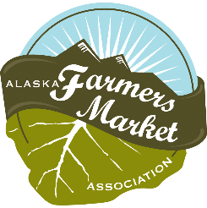
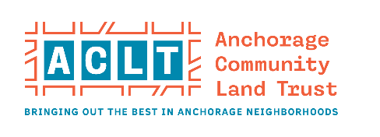
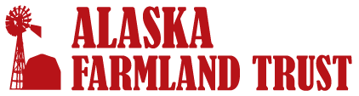
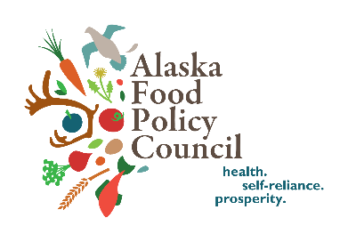
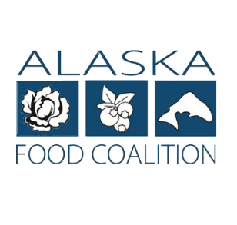
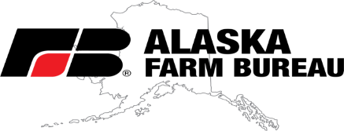
2021 Alaska Food Security Investment Recommendations
Alaska has endless opportunities to improve food security and diversify the economy with some assistance and resources put towards strengthening our food system, from production to distribution to consumption.
The facts around food security in Alaska are concerning:
- Alaska imports roughly 95% of food purchased ($1.9 billion leaving the state)
- We have a 3- to 5-day supply of most foods in grocery stores
- 1 in 7 Alaskans are food insecure, including 1 in 5 kids (pre-pandemic)
Alaska needs more in-state food production. Through increasing infrastructure and developing markets, agriculture could be a key player in building a stronger, more sustainable future for Alaska. A robust food system would increase access to fresh, local, healthy foods, create new economic opportunities, and ensure that we are equipped to handle whatever the future holds.
The American Rescue Plan Act provides a unique opportunity to strengthen Alaska’s food system, which will have tremendous positive impact in both the short and long term. The organizations listed at the top of this page have collaborated to create some broad recommendations and highlight some timely opportunities. Cost estimates/suggested funding levels have been included, as well as examples of organizations with existing experience in facilitating programs in those areas. Note, this is not a complete list and there are many food- focused organizations doing great work around the state.
Local Foods Purchasing Programs
Guaranteed markets will give farmers security in expanding operations, and will help address the heightened levels of hunger Alaska has seen in the past year.
- Local Food to Food Banks: funding program for Food Banks to purchase local foods (agriculture products, fish, value-added, etc.) and distribute to families in need. Example partner: Food Bank of Alaska
- Institutional Purchasing: get the Product Preference Program working for local food purchases.
- Incentive programs for low-income Alaskans to shop at Farmers Markets, Farmstands, Food Hubs: “double bucks” program for SNAP, WIC or voucher system similar to senior farmers market coupons. Example partner: Alaska Farmers Market Association.
Suggested funding level: $3-5 million.

Invest in Infrastructure
Without infrastructure, there is only a certain amount of growth in food production Alaska will realize. Suggested funding levels vary.
- Storage: Cold, dry, frozen storage facilities would assist in increased production and extending availability to products. Consider attaching storage facilities to food banks/pantries allowing for their needs and room for farmers to rent space either with money or food donations. This could include a packhouse/kitchen portion for smaller scale value-added processing. Rural communities are in need of temperature- controlled storage facilities to improve access to fresh foods.
Suggested funding level: $3 million.
Example partner: Kenai Peninsula Food Bank.
- Processing/Manufacturing Facilities: The trend in food purchases is leaning to prepackaged meals (meat/veggies cut, seasoning included and instructions – fresh or frozen) and a facility that processes meat and veggies to a prepackaged, ready-to-go meal will be more enticing to many consumers and provide more Alaska Grown food year-round. Also, this could provide ready-to-go meals for institutions and local, healthy foods with a longer storage life and easier shipping to rural communities.
Suggested funding level: $10-15 million for three hubs across the state in the Interior, the Kenai Peninsula, and the Mat-Su Valley.

- Shared Kitchen Infrastructure: Shared-use kitchen incubators are a proven model with over 200 sites existing in the rest of the country. There is active demand for accessible processing facilities in Anchorage. We recommend investment into a 10,000 s.f. building with rentable kitchen space including manufacturing equipment, cold and dry storage and public facing retail. The facility will serve food-based businesses, with a specific focus on supporting early-stage business as they work to scale within the industry. Users will include market vendors, established bricks and mortar businesses in need of commissary spaces, caterers, wholesale manufacturers, and in-house food retailers.
Suggested funding level $5 million.
Example Partner: Anchorage Community Land Trust Commissary Kitchen & Small Business Incubator.
- Poultry: Egg and meat chicken production would be a quick turnaround for in-state protein production. Poultry farmers rely heavily on USPS to get chicks into Alaska – need incentives for increasing Alaska hatcheries and to include the faster growing meat breeds (i.e. Freedom Rangers). Processing is another need for 2 to 4 Mobile Poultry Processing units (MPUs) around the state would increase ability to process larger numbers. Also work with insurance companies on approving farms’ processing in MPUs (access to insurance). There is the possibility of a state inspector at processing unit and approve schools/state institution’s ability to purchase meat processed in these units.
Suggested funding level: $100,000-$150,000 per processing unit.
- Importing Livestock: The USDA Vet fee is a disincentive to bring in larger loads of livestock for many. One federal vet in Alaska, stationed in Anchorage, requires a fee of $138/hr which includes travel time to and from base. A set up fund would cover travel costs of federal vets for import inspection for 2021/2022. Encourage USDA to either contract with private vets around the state for these inspections or allow virtual inspections.
Suggested funding level: $10,000-20,000.
Example Partner: Alaska Farm Bureau.
- Increased Access to Broadband/Power: Many rural areas in the state (even on the road system) do not have 3-phase power, or reliable access to internet/cell coverage. Alternatives to these are more expensive (generators, satellite phones, etc.). Expanding these infrastructure needs will lower expenses for farmers.
Suggested funding level: $3 million.
Example Partners: ACS and GCI for broadband/satellite communications, Alaska Energy Authority for renewable power sources.
Food System Workforce Development
Many farmers and fishers depend on seasonal workers from outside the state, who often leave with new skill sets. Processors and value-added manufacturing require specialized skills, which tend to be acquired by on-the-job-training. Equipping more Alaskans with food chain skills, which are often transferable among industries, will aid in becoming more proactive in disaster preparedness and pursuit of localized economic resilience. Increasing distributed production, processing, and storage job creation around the state also reduces food waste due to longer product shelf life and is essential for communities to become more self-sufficient. By partnering with educational institutions to build programs that meet the needs of our Alaskan food system, we can create career pathways and long-term workforce.
Suggested funding level: $5 million.
Example Partner: Alaska Seeds of Change.

Transportation
Alaska is a large state and it is inefficient for every sector of our food system to have to transport everything (supplies, products, etc.). There are also big problems with transportation to the off-road communities.
- On road system: Coordination with existing companies with temperature-controlled trucks – i.e., fish processing facilities. Explore what’s available and how to better utilize it. Develop a rail system.
- Off-road system: Need to continue to be able to transport food around the state while also expanding local production/harvesting in communities. Continue funding for ferries, bypass mail, etc., and other systems crucial for distributing food to rural communities. Consider supplemental transportation funding to food banks to help equitably distribute nutritious food throughout the state.
Suggested funding level: $10 million.
Example Partner: Alaska Commercial Company.

